

***PREMIER UNIVERSITY, CHITTAGONG***

***Department of Computer Science and Engineering***

***REPORT***

***Course Name:* Software Engineering and Information System Design Laboratory.**

***Course ID:* CSE 306.**

***Sumbitted to:***

**Dhrubojyoti Das**

**Lecturer of department of CSE**

**Premier University, Chittagong.**

|  |  |  |  |  |
| --- | --- | --- | --- | --- |
| ***Name*** | ***Std ID*** | ***Department*** | ***Batch*** | ***Section*** |
| **Salahuddin Ador** | **1703310201495** | **CSE** | **33rd** | **C5C** |
| **Farhana Akhter** | **1603110201208** | **CSE** | **33rd** | **C5C** |
| **Muntahina Tabassum** | **1703310201531** | **CSE** | **33rd** | **C5C** |

***Date of Submission:*  20th October, 2020**

***Introduction:***

***An e-commerce website is an information technology method in which traders, businessmen can sell products or do services and the customer can purchase on that website electronically by using the internet on the mobile and computer. It means an e-commerce website is an online shop. e means electronic. Commerce means business. The website means the group of HTML web pages and that is created to market/sell information/products/services. From a bigger perspective, every website on the internet is the eCommerce Website. We, in the era of technologies, are highly dependent on online. It can rather be shoping, communicating to our closed ones or others. . For making shopping more easier, nowadays different catagories of e-commerce sites are being created. We have worked on a project of e-commerce site where different catagories products can be sold. Admin will have the authourity to sell products and the user will only choose what they want and get it only when the products are in stock. The user will get their desired product at their home through courier service or home deleivery from the site. Shopping gets easier and more fun as the user don’t need to roam from shops to shops for their desired products. Shopping is now just one finger tap away and will be home within required time.***

***Objective:***

***The objective of our e-commerce site is to deleiver the best products to our customer within reasonable prices and estimated time. We only want***

***our customer satisfaction and happiness through selling them best products.***

***History:***

[***E-commerce***](https://www.miva.com/blog/what-is-e-commerce/) ***is the buying and selling of products or services via the Internet. For many people, ecommerce is something we participate in on a daily basis, like*** [***online bill payment or purchasing from an e-tailer.***](https://www.miva.com/mivapay?utm_source=organic&utm_medium=blog&utm_content=the-history-of-ecommerce-how-did-it-all-begin)

***Nowadays the thought of living without ecommerce seems unfathomable, complicated and an inconvenience to many. It wasn’t until only a few decades ago that the idea of ecommerce had even appeared.***

***The history of ecommerce started 40 years ago and, to this day, continues to grow with new technologies, innovations, and thousands of businesses entering the online market each year. Electronic Data Interchanges and teleshopping in the 1970s paved the way for the modern day ecommerce store. The history of ecommerce is closely intertwined with the history of the internet. Online shopping only became possible when the internet was opened to the public in 1991.*** [***Amazon.com***](https://amazon.com/) ***was one of the first ecommerce sites in the US to start selling products online and thousands of businesses have followed since. The convenience, safety, and user experience of ecommerce have improved exponentially since its inception.  This article will address some of the key players and milestones of ecommerce.***

***Features:***

***Features as User:***

* ***Registration and Login as User.***
* ***Send User friend request.***
* ***Searching and finding required products.***
* ***Ordering required products.***
* ***Details about E-commerce site.***
* ***Adding ratings and reviews and feedback.***
* ***Payment with card or cash on delivery in some estimated areas decided by admin***
* ***Getting home deleivery***

***Features as Admin:***

* ***Registration and Login as Admin.***
* ***Accepting User friend request.***
* ***Inserting, deleting and updating products.***
* ***Tracking and managing customer’s desired ordered products.***
* ***Viewing paying details.***
* ***Summary of customer’s information.***

***Methodology:***

***Process model:***

***In our project we have used Waterfall model. In our project,each stage construct a well-defined product or output which is passed onto the next stage as an input just like a stream of water. Once the stream of water, falls down it cannot flow back up. Similarly, once the product of a stage is passed to the next stage it cannot be reverted. So, we can say that this entire software development process behaves like a series of tiny waterfalls.***

***Use case diagram:***

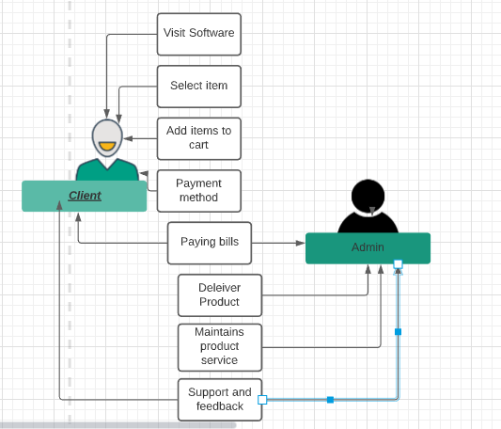

*Fig 1: Use case Diagram*

***ER Diagram:***

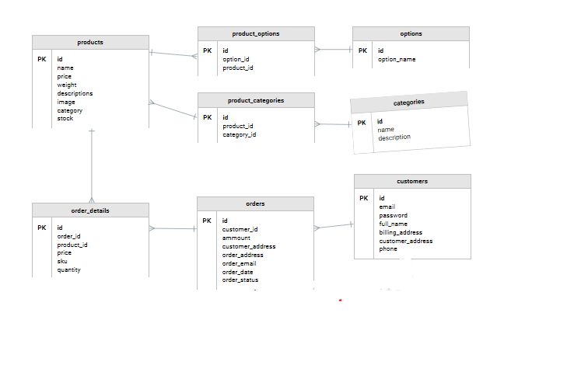

*Figure 2: ER diagram*

***Activity Diagram:***

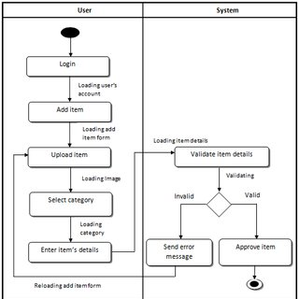

*Figure 3: Activity Diagram*

***Logical DFD:***

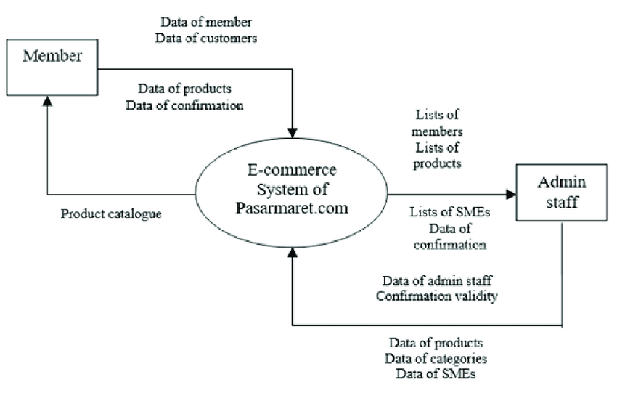

*Figure 4: Logical DFD*

***Limitations:***

* ***Category work has not been done.***
* ***Adding product has not been done.***

***Future work:***

***We are trying our best to make our project successful. E-commerce app is now at hands to shop. Selecting products, ordering products and getting in to home wherever the location of the user is made useful impact on national wide.***

***Our future plans for our project are:***

* ***Products will be added.***
* ***Products will catagorised.***
* ***The location of the customer will be tracked by app to deleiver product.***
* ***Within a short period products will be at the door of customers.***
* ***Our project will be used both nation and international wide.***

***Conclusion:***

***Our main purpose is to create a E-commerce site app that will be user friendly. We hope that our project will help admin to create a close relation with user. Our aim is also to communicate people who are willing to buy products and the people who are willing to sell products through online in few touches of software. It will less time consuming and user friendly too.The customer needs an account, send request to be member, add ordered products to cart and get deleivery within estimated time given by Admin.***

***Reference:***

* ***www.google.com***
* ***https://getbootstrap.com***
* ***https://w3schools.com***
* [***www.youtube.com***](http://www.youtube.com)
* [***www.GitHub.com***](http://www.GitHub.com)
* ***https://lucid.app***